LOL1n Wi-Fi Based Motor Controller

Usage Guide

# Introduction

The **LOL1n WiFi Lid Controller** is a smart, web-based system designed to remotely open and close a physical lid using a servo motor, powered by the ESP8266 NodeMCU module. It provides a user-friendly Bootstrap-powered dashboard accessible from any device connected to the same WiFi network. With just a tap or click on a mobile or desktop browser, users can control the lid movement wirelessly. This project demonstrates a practical application of IoT in automation, blending embedded hardware control with real-time web interface interaction. It is ideal for smart home systems, mini vending machines, secure containers, or educational tech demos.

Note: SR_COM_LAB_WIFI / bms@admin25

# Setup

1. Connect Micro-B USB Male to USB 2.0 Type A Cabel With The LOL1n Board and To Computer
2. Open Laptop/PC
3. Connect To WiFi
4. Windows Key + R – CMD and enter
5. Type “Netsh WLAN show interfaces” and hit Enter
6. 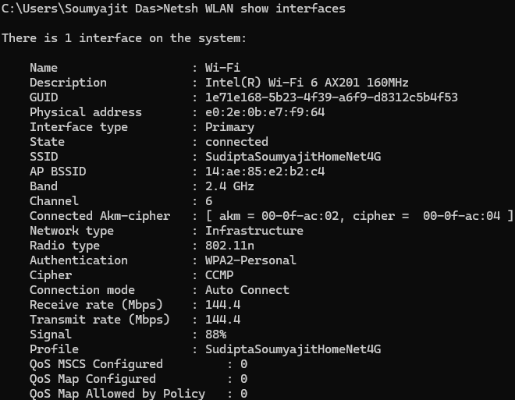
7. Keep it Open
8. Install Arduino
9. Open The .ino File
10. Goto any browser & download driver from here: <http://www.wch.cn/download/CH341SER_EXE.html> and then install it.
11. Goto File > Preference & Under Additional Board Manager URLs, add <http://arduino.esp8266.com/stable/package_esp8266com_index.json>
12. Goto the USB Listing & Select The COM with (USB) showing and then select the board NodeMCU 1.0 (ESP-12E Module) & Install All The Dependencies & Click on OK
13. Now, Modify The Following Parts
14. 
15. Here in the ssid, paste the SSID from the cmd and write the password that is known.
16. After this click on verify and wait and then goto upload and wait.
17. Click on RST in board and then an IP showed up probably <http://192.168.29.41/>
18. Go ahead, copy and paste in the pc browser and test it.
19. Make sure that the module is placed at a place where range is good. If it went blank CTRL + R
20. After these, simply unplug and exit all applications.
21. Connect it with charger and open the URL in Android ® or iOS ® and then work with it.

!! That’s AII !!

# Note

* If the screen shows white then refresh it will work.
* If the motor doesn’t respond, make sure to restart the module or press RST.
* Don’t loose any wire or else the firmware will corrupt.
* Follow the exact steps.
* Don’t Add anything heavy to the motor where it will not able to handle it.